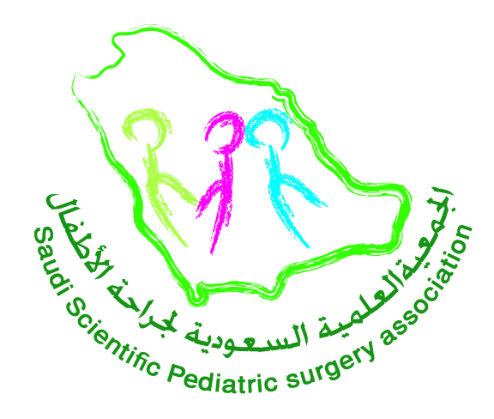
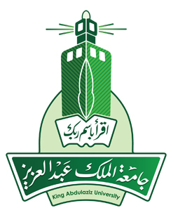

Advanced Dry laparoscopic Workshop
23 April 2017 / 26 Rajab 1438

REGISTRATION FORM

Title: [ ] Prof. [ ] Dr.

Gender: [ ] Male [ ] Female

First Name
Middle Name
Family Name
Institution
Position |  |  |  |  |  |  |  | Specialty:
SCOHS  Registration ID. |  |  |  |  |  |  |  | Valid until:
E-mail address
Address
P.O.Box
Tel. No. | Office No: |  |  |  | Mobile: |  |  |  | Fax No:

REGISTRATION FEES 1000 SR

For More Information Please contact
Mr. Hisham Hamdy
Secretary of the Saudi Association of Plastic Surgery (SSAPS)
Mobile. 0558887630
Tel.: +966(012)6401000 Ex.21221

